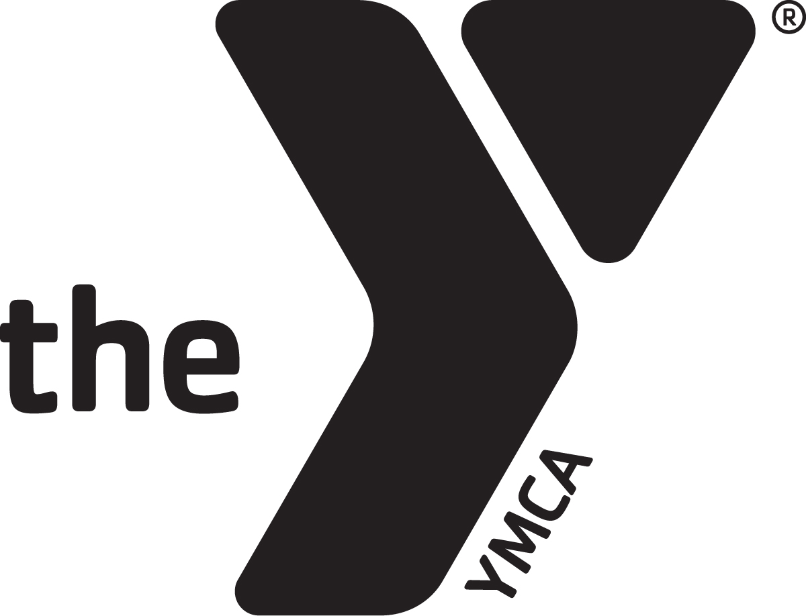
Safety Now – Skills for Life
Illinois YMCAs Drowning Prevention Program
Funding Application

Important Information – please read prior to applying
Application Period: January 27, 2025 – February 14, 2025
Programs must be offered between October 1, 2024 and August 31, 2025
Target Age Group: Youth ages 4-14 years
Definitions: Program – the entire course of lessons/session you provide to a set group of participants. Session – the number of lessons or times the program group meets.
The scope of grant awards will be based on interest from YMCAs statewide. Numbers and sites funded per association may be limited in order to ensure access to programs across the state.
This is a reimbursement grant with funding being paid at the completion of our program(s). Rate of reimbursement will be $80 per participant, with participants required to attend at least 50% of the program. This rate is inclusive of program costs and additional costs as needed, such as providing swimsuits and transportation. Required data must be submitted with reimbursement request no later than 30 days after completion of program in order to receive payment. Final programs (those ending 8/31/25) must be received by 9/30/25.
We recommend utilizing Y-USA’s Safety Around Water curriculum in order to meet the grant requirements of teaching the skills of jump, push, turn, grab and swim, float, swim. We understand that not all programs will be able to meet for 8 sessions of 30 minutes each, but programs must provide a minimum of 3 hours of instruction. Any request for exceptions must be outlined below on how required skills can be delivered and how they will be measured. You can find the Safety Around Water curriculum and information here: https://link.ymca.net/intranet/pages/715?lang=ENG

Application – please complete the following information:
YMCA Name
YMCA Address
Contact Name
Contact Email
Contact Phone Number
Name of Location where program will take place
Address of program location
Program location contact email & phone number if different than above
Are you currently offering a drowning prevention program?

Please Answer the Following:
- When do you anticipate your drowning prevention program taking place (please be as specific with dates as possible)?

- What will the time frame and length of your drowning prevention program be (Ex. 1 time a week for 8 weeks for 30 minutes each, 1 time a week for 4 weeks for 60 minutes, two 90-minute sessions, three 60-minute sessions, a full day program, etc.)?

- How will your curriculum be structured/offered to ensure participants will learn the required skills of jump, push, turn, grab and swim, float, swim? (if utilizing Safety Around Water curriculum – note that here)

- Based on your proposal above, what barriers may impede equitable access and participation of youth or groups of youth in your area?

- Based on the barriers identified, what steps will you take to address such barriers to equitable access and participation your drowning prevention program?

- Do you anticipate partnering with any organizations or groups in your community? If yes – who?

- How many youth do you anticipate serving with this program?

Please answer ‘Yes’ or ‘No’ to the following:
My YMCA agrees to provide information to the Illinois State Alliance of YMCAs on the following:
- Number of programs run – including dates of start and completion
- Number of youth who participated per session
- Demographic information including age, race & ethnicity (can be composite)
- Pre and post test results on the required skills of jump, push, turn, grab and swim, float, swim (method of reporting must demonstrate progress or lack thereof over the course of the program and reported in the aggregate – ex 15 out of 20 increased in skills or 75%, etc.) You can utilize SAW progress tracker per participant (https://link.ymca.net/user/document/11702 ) or a simple aggregate tally sheet (below).
□ Yes - we agree □ No – we do not agree
My YMCA agrees to utilize the ‘Safety Now – Skills for Life’ promotional materials to align a single, concise message throughout the state.
□ Yes - we agree □ No – we do not agree
My YMCA agrees to promote this program to area leaders and to invite them to observe, take part in the program (civic leaders, local health departments, elected officials, etc.)
□ Yes - we agree □ No – we do not agree
My YMCA understands that this funding is a pass-through grant from the federal government and that we cannot engage in ‘lobbying’ elected officials with these funds. We do understand we can educate leaders and stakeholders on the health/safety issue of drowning and how drowning prevention programs can help keep kids and families safe.
□ Yes - we agree □ No – we do not agree
My YMCA understands that the funding will be given at the rate of $80 per participant, with participants required to attend at least 50% of the program. This rate is inclusive of program costs and additional costs as needed, such as providing swimsuits and transportation.
□ Yes - we agree □ No – we do not agree

My YMCA understands that this is a reimbursement grant, with payment available at the end of the program. The following data must be submitted within 30 days of the end of the program and approved by the Alliance:
- Number of programs run – including dates of start and completion
- Number of youth who participated per session
- Demographic information including age, race & ethnicity
- Pre and post test results on the required skills of jump, push, turn, grab and swim, float, swim (method of reporting must demonstrate progress or lack thereof over the course of the program and reported in the aggregate – ex 15 out of 20 increased in skills or 75%, etc.) - See above for recording sheet examples
□ Yes - we agree □ No – we do not agree
Signed:

_____________________________ ________________________________
YMCA Program Contact YMCA CEO

Printed Name:

_____________________________ ________________________________
YMCA Program Contact YMCA CEO

Please submit this application and other required materials via email to:
christy.filby@illinoisymcas.org

For questions, contact:
Christy Filby, Director of Public Policy and Statewide Initiatives
Illinois State Alliance of YMCAS
christy.filby@illinoisymcas.org or 309-798-3423.
Alliance CDS Drowning Prevention Grant Pre - Post Tally Sheet
SKILLS | DATE | DATE
Submerge | Achieved - Pre (Tally) | Achieved - Post (Tally)
Submerge face
Totals
Submerge, bob independently
Totals
Swim, float, swim
Front glide, 5 ft., exit
Totals
Back float, 10 secs, roll, front glide, exit
Totals
Swim, float, swim, 10 ft.
Totals
Jump, push, turn, grab
Jump, independently
Totals
Jump push turn, grab, assisted
Totals
Jump, push, turn, grab
Totals
Stage Assignment | Beginning Date | End Date
Beginner
Total
Intermediate
Total
Advanced
Total
Topics Taught (If not taught, enter N/A) | Date
Benchmark skills
Reach or Throw, Don't Go
Call 911
CPR
Backyard Pools
Pool Drains
Life Jackets
Boating

