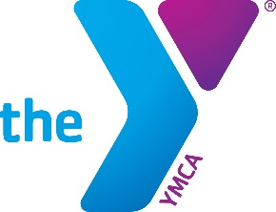 

**Illinois State Alliance of YMCAs’**

**Illinois Statewide 2Ball Tournament**

**Pledge Agreement**

The **Illinois State Alliance of YMCA’s (Alliance)** has entered into a five-year marketing agreement with the IHSA and IESA to promote the YMCA in multiple state sport championships, websites and streaming networks. In addition, the Alliance has created a **Skills Competition Task Force (Task Force)** charged with developing and implementing a **Sports Skills Competition (Skills Competition)** to be hosted at local YMCA Associations that will result in finalists competing at the state championships for both basketball and football.

By completing this Pledge Agreement, you are indicating your YMCA’s commitment to participate in the Skills Competition as outlined below:

* **The Alliance agrees to:**
  + Secure sponsorship for each Skills Competition to help underwrite the cost of each YMCA Association.
  + Provide a structured competition event plan that each local YMCA Association can implement at each of their YMCA branches, including competition rules, and a competition outline of how best to implement the competition.
  + Provide all marketing assets to assist the local YMCA in their promotion of the competition.
  + Provide all necessary resources to support the implementation of each event, including participation giveaways, required branded supplies, and other supplies deemed necessary by the Task Torce.
  + Host all state finalists and their families at the state competitions.
* **Our YMCA agrees to:**
  + Host both the basketball and football Skills Competition as prescribed by the Alliance Task Force.
  + Use all required marketing assets to promote the local event as outlined in the competition outline.
  + Complete all competition scores to the Task Force as outlined in the competition outline.
  + Provide staff support for the state final competition, if a participant from your YMCA makes it to the state finals.
  + Work with the State Alliance and Skills Competition Task Force to ensure local participants are supported as needed to attend the state final competition.

______________________________________________________________________

YMCA Name

____________________________________ _________________________

CEO Signature Date