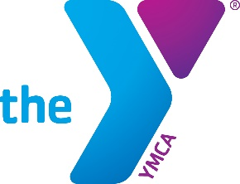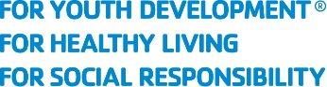

Illinois State Alliance of YMCAs
Statewide 2Ball Tournament Participation Form

Please return this form to wendy.bonilla@illinoisymcas.org

Our YMCA would like to participate in the 2026 Statewide 2Ball Tournament

YMCA:

Contact Name:

Email Address:

Phone Number:

The Illinois State Alliance of YMCAs has entered into a five-year marketing agreement with the IHSA and IESA to promote the YMCA in multiple state sport championships, websites and streaming networks. In addition, the Alliance’s Skills Competition Task Force has developed a Statewide 2Ball Tournament with round one competitions to be hosted at local YMCA Associations. Top scoring teams in each age and gender bracket will compete in championships during half time of IHSA State Championship Basketball games March 7th (girls) and March 14th (boys). By completing this Pledge Agreement, you are indicating your YMCA’s commitment to participate in the Statewide 2Ball Tournament as outlined below:

- The Alliance agrees to:
  - Provide a structured competition event plan that each local YMCA Association can implement at each of their YMCA branches, including competition rules, and a competition outline of how best to implement the competition.
  - Provide all marketing assets to assist the local YMCA in their promotion of the competition.
  - Provide participation giveaways and championship prizes
  - Host all state finalists and their families at the state competitions.

- Our YMCA agrees to:
  - Host local 2Ball competitions by February 1, 2026.
  - Report winning scores by 5pm on February 2, 2026.
  - Utilize provided marketing assets to promote the local event.
  - Provide staff support for the state final competition, if a participant from your YMCA makes it to the state finals.
  - Work with the State Alliance and Skills Competition Task Force to ensure local participants are supported as needed to attend the state final competition.

